**Rainsville Chamber of Commerce**

**Scholarship Disc Golf Tournament**

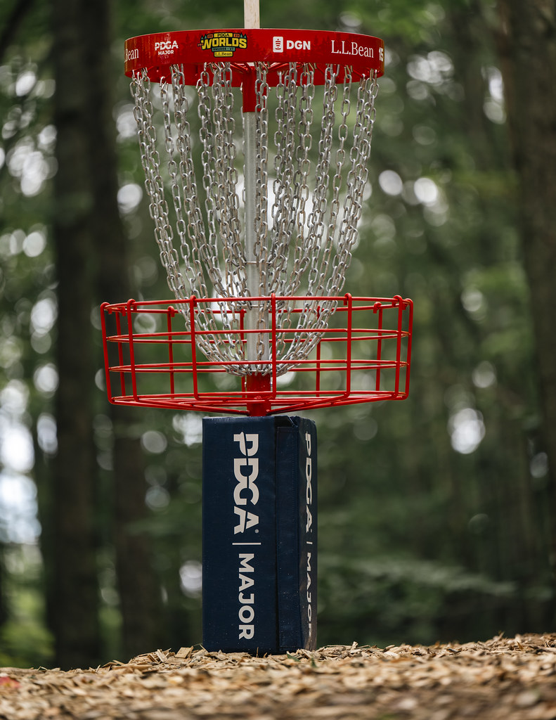

**Rainsville Chamber of Commerce**

PO Box 396

**Rainsville, Alabama 35986**

**256-638-7800**

**April 5th, 2025**

**SPONSOR FORM**

Thank you for helping make the tournament and scholarship program successful.

**Yes, we want to be a golf tournament sponsor**

**SPONSOR NAME: ______________________________________**

Contact: ____________________

Address: ____________________

_________________________

Phone: ________________________

E-mail: ________________________

**Sponsor Levels**

**_____: Title Sponsorship- $2,500 - $5,000**

**_____: Corporate Sponsorship - $500 - $1,000**

36-48 banner

**_____: Hole Sponsorship - $50**

24x18 sign at a tee box